In this section, you are going to learn about two topics:
1. Buddhist Cosmology and Cosmogony
2. Mahāyāna Buddhism
Buddhist Cosmology and Cosmogony
Please watch the following PowerPoint presentation:
Please read the Buddhist scripture known as the Aggañña Sutta (read until section 11 at least, although the entire scripture is recommended).
- https://suttacentral.net/dn27/en/sujato
Mahāyāna Buddhism: Introduction

In general, monastic forms of Buddhism are highly scholastic and literate. Written materials were historically produced by Buddhist monks for other Buddhist monks. Therefore:
- Buddhist scriptures presume a highly specialized and educated readership. Buddhist scriptures were generally not written for laypeople, but rather for monks who would spend their entire lives learning about Buddhism (all day, every day!).
- Because of this presumed specialized readership, Buddhist scriptures are full of technical "in-group" vocabulary and concepts, which are not explained.
- Therefore, do not expect original (i.e., "primary") Buddhist scriptures to be simple, accessible, straight-forward, easy to understand, etc. Although I will do my best to help us learn about these, it is normal that Buddhist scriptures should be confusing and complicated to us as laypeople in the 21st century!
- Sometimes people think that Buddhism is pretty simple, peaceful, mostly about meditation, etc. Nothing could be further from the truth. Historically, Buddhism easily rivaled any other premodern culture in the world in terms of its sophistication and intricacy. Over 2500 years (a very long history!) Buddhism became increasingly scholastic, literate, bureaucratic, intricate, and economically and politically involved.
This is particularly true of this section of the course. Therefore, you may feel frustrated and overwhelmed by the dizzying array of intricate and tricky concepts below. Do not try to learn all of it in one sitting. Read a little every day, and if there is something you don't understand, Google it! If you don't understand something, read a few different descriptions of the same thing.
- Buddhism developed into three broad forms or yānas (literally "vehicles"), meaning modes or methods of practice, but also regarded as separate schools or systems.
  - Śrāvaka-yāna = "Vehicle of Listeners" (meaning vehicle of disciples). Today, this vehicle is widely referred to as Theravāda "Doctrine of Elders." Śrāvaka-yāna also refers to the early schools of Buddhism before the subsequent two yānas came into existence. Sometimes this vehicle is (pejoratively) called Hīnayāna (meaning "Lesser Vehicle") in Mahāyāna literature. Up until this point in the class, we have been learning about Śrāvaka-yāna, mostly in the abstract. Although Śrāvakayāna is an early form of Buddhism, it continued to develop after the emergence of Mahāyāna Buddhism both within and outside of India.
  - Mahā-yāna = "Great Vehicle" (the topic of this lesson)
  - Vajra-yāna = "Thunderbolt Vehicle" or "Diamond Vehicle" (to be discussed later in the course)
- Although it's a complicated history, each school evolved subsequently, one after the other, within India (and then, they developed side-by-side, interacting with one another). At the same time, each yāna became popularized in different Asian countries, as Buddhism spread. This map illustrates where in Asia these yānas appear as the dominant forms of Buddhism.
The Three yāna-s Across Asia
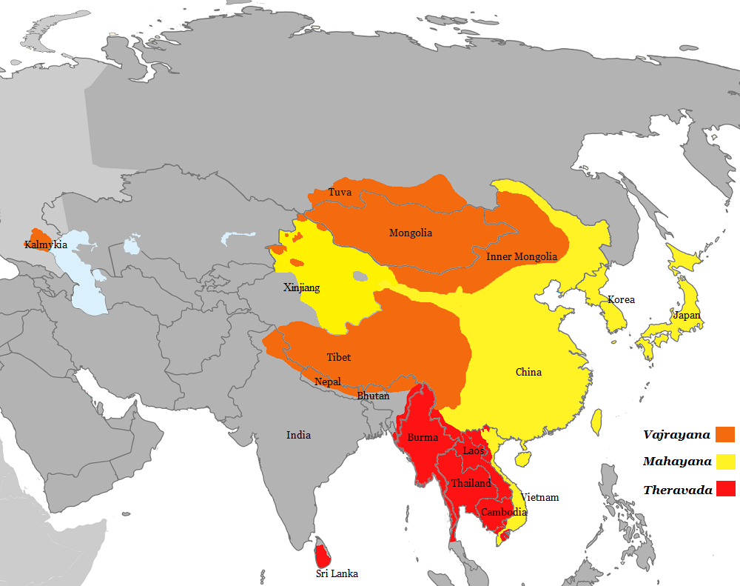
* In this section of the course (Part 7), I will explain some introductory ideas that developed in Indian Mahāyāna literature. Although these ideas form the basis of East Asian Buddhism, I will not discuss the development of these ideas in East Asian yet (still to come in this course).
Mahāyāna Buddhism: What is it?
- It is not really a “school,” but a set of views and values. Mahāyāna Buddhism does not have a separate Vinaya (body of literature relating to monastic discipline), for instance.
- Its origins are nicely thought of as a "movement," which began to establish itself between the 1st and 5th centuries C.E.
- A series of developments in Buddhist thought.
Origin of the Mahāyāna Scriptures
- A group of scriptures (sūtras), beginning around the 1st century C.E. are classified as "Mahāyāna" scriptures.
- Many of these scriptures were originally composed in Sanskrit. Today, however, few Sanskrit originals remain, but the scriptures are preserved in Chinese and Tibetan translations.
  - The Theravāda / Śrāvakayāna Buddhist scriptures (that we have studied up until this point are preserved in the Pali language).
- These are accepted as canonical (i.e., authoritative words of the Buddha) by Mahāyāna (and Vajrayāna) Buddhism, but they are not accepted as canonical by Theravāda / Śrāvaka-yāna Buddhism.
  - How could the Mahāyāna scriptures claim to be the words of the Buddha...
    - even though they emerged many hundreds of years after the Buddha had died and...
    - there was no record of these scriptures during this time?
      - Mahāyāna Buddhists account for this discrepancy in various ways. Most famous is the claim that although the Buddha did indeed speak (i.e., compose) the Mahāyāna scriptures himself, most human beings were yet incapable of understanding them or using them effectively. Thus, the scriptures had to be stored away until the suitable time emerged when these teachings could be beneficial to humans. In one legend, a group of Mahāyāna were safeguarded by the nāgas, semi-divine, supernatural creatures (generally appearing as half-human, half-serpent in nature). The renowned Buddhist teacher Nāgārjuna (c. 150 – c. 250 CE) was offered the scriptures by the nāgas. See this episode in the 19th century Tibetan painting below:
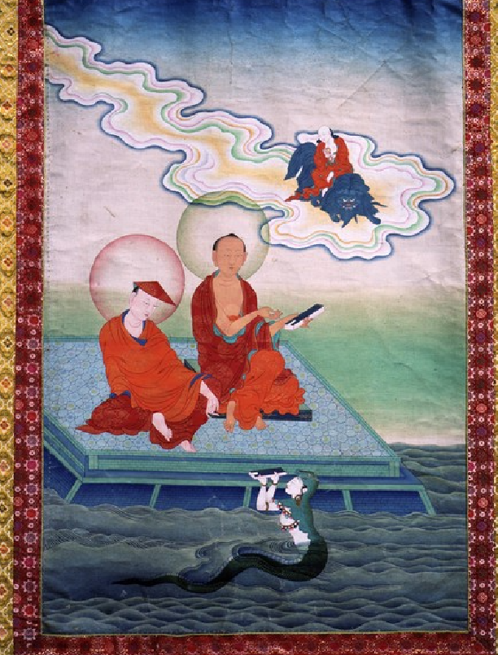
* Nāgārjuna is seated on the right (his disciple on the left), the nāga in the water, and the Buddhist god Mañjuśrī riding a blue lion in the sky (for full details, see https://www.himalayanart.org/items/15549)
Topics Found in Mahāyāna Scriptures
The Mahāyāna scriptures emphasize the following ideas:
“Buddha Nature”
Mahāyāna scriptures often describe an innate nature known as Tathāgatagarbha, which means "Buddha womb" or "Buddha embryo." It is a sacred nature innate within each being, already awakened, that is the basis for becoming a Buddha. Although it exists within us, we do not recognize it. In fact, Mahāyāna Buddhist scriptures tend to minimize the difference between samsara and nirvana; nirvana is not some far away place; nirvana is just samsara misunderstood/misapprehended.
“Emptiness” (Śūnyatā)
Mahāyāna scriptures emphasize that objects (physical, non-physical--everything) have no intrinsic reality (svabhāva); they are empty (śūnya) of reality. All objects are merely conceptual entities. Emptiness of the self is taught in early Buddhism (as we have already encountered in the doctrine of no self, but Mahāyāna teaches that all reality is inherently empty. Read this great explanation of emptiness: https://www.huffpost.com/entry/emptiness-most-misunderstood-word-in-buddhism
One of the reasons why emptiness became emphasized in Mahāyāna Buddhism is because an earlier type of Buddhist literature known as the Abhidharma (the third "basket" of Buddhist scriptures) taught that phenomena are reduced down to small particles called dharmas. Read my handout on this: Handout on Abhidharma — Buddhism. Mahāyāna scholars considered the teaching of these particles to be problematic since they presumed some level of stability or "realness."
"The Two Truths" (Dvasatya)
Things only have stable reality according to conventions (what is known as "Conventional Truth" or "Conventional Reality"). For example, we call a table "a table" as a convention. Ultimately, it does not possess any "table-ness"; it is merely a sum of parts (e.g., top, legs, nails, paint). Those components are further divided into their own component parts down to a flux of changing elements fully interacting with the environment, which is why everything changes and ultimately degrades. This, known as Emptiness, is "Ultimate Truth" or "Ultimate Reality." Together, "Conventional" and "Ultimate" are known in Buddhism as "The Two Truths."
"Selfless Compassion" (Maitrī)
We already learned that selfless compassion is an important virtue in the Jātaka tales. In Mahāyāna Buddhism, selfless compassion is the basis of the Buddhist path. This is seen in a variety of ways.
- Bodhisattva:
  - The hero or saint of the Mahāyāna path is called the Bodhisattva: a being (sattva) whose nature is awakening (bodhi). The hero of Theravāda / Śrāvakayāna Buddhism is known as an arhat "one who is worthy," meaning one who has achieved nirvana. Bodhisattvas are those who attain nirvana for the sake of all beings. Although they are awakened, they stay in samsara to help other beings.
  - The path to becoming a bodhisattva emphasizes six perfections (paramitā):
    - giving (dāna)
    - morality (śīla)
    - patience (kṣānti)
    - energy (virya)
    - meditation (dhyāna)
    - wisdom (prajñā)
      - The Jātaka tales also include these perfections, as we have already seen, but the tales do not approach these as prescriptions (rather, these perfections describe and inspire awe in the Buddha). Mahāyāna Buddhism prescribes these as part of the path.
  - Those embarking on the bodhisattva path take vows such as:
However innumerable the sentient beings, I vow to save them all.
However inexhaustible the passions (klesas), I vow to extinguish them all.
However immeasurable the dharmas, I vow to master them all.
However incomparable the truth of the Buddha, I vow to attain it.
- Vegetarianism
  - Because compassion is emphasized in Mahāyāna Buddhism, vegetarianism becomes a major part of Buddhism. Here are a few passages from Mahāyāna Buddhist literature about vegetarianism:
There are no beings who have not been one’s mother, who have not been one’s sister through generations of wandering in beginningless and endless saṃsāra. Even one who is a dog has been one’s father…. Therefore, one’s own flesh and the flesh of another are a single flesh, so Buddhas do not eat meat (Aṅgulimālīya Sūtra).
When even looking at outer forms stimulates a craving for tasting the delicious flavor of animal flesh, let the Bodhisattva, whose nature is sympathetic compassion and who regards all sentient beings as if they were his or her only child, totally refrain from eating animal flesh (Nirvāṇa Sutra).
[They] who do not wear silk, leather boots, furs, or down ...and who do not consume milk, cream, or butter, can truly transcend this world. Both physically and mentally one must avoid the bodies and the by-products of beings, by neither wearing them or eating them. I say that such people have true liberation (Śūraṅgama Sūtra).

"Skillful Means" (Upāya)
Mahāyāna Buddhism emphasizes a wide array of "skillful means" (upāya): teaching tools that help beings gain liberation. Mahāyāna literature considers that previous forms of Buddhism were overly constrained by morality (e.g., monastic rules), which limited potentially helpful skillful means. We already encountered some of this tension in the Jātaka tales, in which the Buddha-to-be went against normative monastic rules in order to help beings. Because bodhisattvas take vows to help bring all beings to liberation, they must engage in whatever techniques are necessary to do so. We already encountered the idea of the Buddha's skillfulness as a teacher in reference to the Devadatta narratives.
An example of a controversial skillful means embraced by the Mahāyāna tradition is lying. Normally, Buddhist monks and teachers should not lie. However, when used as a greater good (for the purpose of helping beings become liberated), lying can be useful (remember: the Buddhist path is better thought of as practical rather than holy or sacred). One famous lie is found in the Mahāyāna scripture called the Vimalakīrti Nirdeśa Sūtra. In this scripture, the Buddhist hero, named Vimalakīrti, helps his students become liberated by lying to them. He lies that he is sick and dying so that he can illustrate the inherent emptiness of the body. He summons his students to his bedside, where he delivers a sermon, which is successful: his students attain nirvana!
Here is an excerpt of his sermon, which is one of my favourite descriptions of the impermanence of the body anywhere in Buddhist literature:
"Friends, this body is so impermanent, fragile, unworthy of confidence, and feeble. It is so insubstantial, perishable, short-lived, painful, filled with diseases, and subject to changes. Thus, my friends, as this body is only a vessel of many sicknesses, wise men do not rely on it. This body is like a ball of foam, unable to bear any pressure. It is like a water bubble, not remaining very long. It is like a mirage, born from the appetites of the passions. It is like the trunk of the plantain tree, having no core. Alas! This body is like a machine, a nexus of bones and tendons. It is like a magical illusion, consisting of falsifications. It is like a dream, being an unreal vision. It is like a reflection, being the image of former actions. It is like an echo, being dependent on conditioning. It is like a cloud, being characterized by turbulence and dissolution. It is like a flash of lightning, being unstable, and decaying every moment. The body is ownerless, being the product of a variety of conditions.
"This body is inert, like the earth; selfless, like water; lifeless, like fire; impersonal, like the wind; and nonsubstantial, like space. This body is unreal, being a collocation of the four main elements. It is void, not existing as self or as self-possessed. It is inanimate, being like grass, trees, walls, clods of earth, and hallucinations. It is insensate, being driven like a windmill. It is filthy, being an agglomeration of pus and excrement. It is false, being fated to be broken and destroyed, in spite of being anointed and massaged. It is afflicted by the four hundred and four diseases. It is like an ancient well, constantly overwhelmed by old age. Its duration is never certain - certain only is its end in death. This body is a combination of aggregates, elements, and sense-media, which are comparable to murderers, poisonous snakes, and an empty town, respectively. Therefore, you should be revulsed by such a body. You should despair of it and should arouse your admiration for the body of the Tathagata."

(The entire scripture is found online: https://www2.kenyon.edu/Depts/Religion/Fac/Adler/Reln260/Vimalakirti.htm).
"Three Buddha Bodies" (Trikāya)
One of the most significant developments in Mahāyāna is the Three Buddha Bodies doctrine, which reformulates the nature of reality. This doctrine teaches that buddhas (i.e., awakened beings, including the historical Buddha) have three "bodies" (kāya). These are:
- The Dharmakāya ("truth body" or "reality body"): This is the non-manifested/undifferentiated source out of which all buddhas emerge and return to. In other words, all buddhas are manifestations of the dharmakāya. It is synonymous with “Emptiness” (Śūnyatā), as explained above.
- The Saṃbhogakāya ("body of enjoyment"): This is a non-physical body (or "subtle" body of a buddha). Buddhas may manifest in this non-physical form to teach in visions, meditations, non-human realms, or "pure lands"--see about the pure lands later). Many famous Buddhas that appear in Saṃbhogakāya form are: Amitābha and Mañjuśrī--more on these later).
- The Nirmaṇakāya ("physical/manifest body"): This is a physical manifestation of the dharmakāya. For example, the historical Buddha.
Many Buddhas and Bodhisattvas
In Mahāyāna Buddhism, there are many different buddhas and bodhisattvas. This is not surprising, since there are countless manifestations of the dharmakāya. All of these buddhas and bodhisattvas try to aid beings reach liberation. A buddha refers to a fully awakened being; a bodhisattva postpones his/her full liberated in order to help other beings (nevertheless, bodhisattvas are regarded as awakened beings anyways). Here are two important examples:
- Amitābha (also known as Amida or Amitāyus): "The Buddha of Immeasurable Light and Life," the major deity associated with Pure Land Buddhism--more on this later. Read the entry on Amitābha from the Digital Dictionary of Buddhism. You can login using the word "guest" (no password required): http://www.buddhism-dict.net/cgi-bin/xpr-ddb.pl?q=%E9%98%BF%E5%BD%8C%E9%99%80 (
- Avalokiteśvara: The Bodhisattva of Compassion. Please read the following short article about this deity: https://www.buddhistdoor.net/features/the-many-forms-of-avalokiteshvara
Pure Lands
Together with the Three Buddha Bodies (above), the concept of the "Pure Land" became one of the most important developments in Mahāyāna Buddhism. The Pure Land is a celestial realm (located outside normal space and time) inhabited by a buddha or bodhisattva in Saṃbhogakāya form. In short, Buddhas and Bodhisattvas can bring human beings to the Pure Land at the time of death. These humans will then live in the Pure Land until they themselves become awakened. The idea is that the Pure Land is a purpose-built environment, completely free from the defects of samsara, so that beings may easily gain liberation.
The best known and most influential of these is known as Sukhāvatī "the Western Paradise," which is governed by Amitābha Buddha. According to Mahāyāna literature, Amitābha vowed to save all beings from samsara and thus created the Western Paradise in order to help them.
How to gain rebirth in the Pure Land?
Watch the video below for the answer. This is an animation of one of the two most important Indian Buddhist Mahāyāna scriptures on the topic of the Pure Land. This video animates the Longer Sukhāvatīvyūha Sūtra, also known as "The Buddha Speaks of the Infinite Life Sūtra." This is from the same series you watched before about Devadatta. Keep in mind it is originally made in Japanese and narrates an Indian scripture, however it is dubbed in Chinese (there are English subtitles at the bottom).
- https://www.youtube.com/watch?v=1l0he9KHqAA

Now that we have learned about several Indian Mahāyāna Buddhist ideas, we will be better able to understand Buddhism in East Asia (coming up later in the course).

